How to run BucStop locally

To run locally you need to run the Bucstop project and the GameMicroService project simultaneously so they can communicate together. You can technically run Bucstop without the microservice but it will attempt to call the API every time it passes over it in the code and then eventually timeout.

There are two options to run locally: in Visual Studio or in a local docker container.

- If you run locally in a docker container, you must update the appsettings.json file in BucStop to point to the URL of the microservice in http. You can’t use https since Visual Studio can’t help you create ssl dev certs locally.
- So change “Micro”: "https://localhost:7223" to “Micro”: "http://localhost:4200". Make sure
the port numbers are correct.
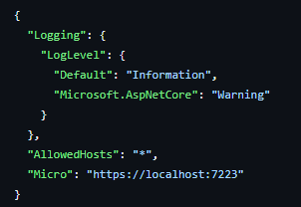

First Option: Running in Visual Studio

- Open the *.sln file with Visual Studio.

- Once the project opens, make sure the project is selected on the top next to the play button. If it isn’t, you can click the arrow to the right of the play button and select the project:
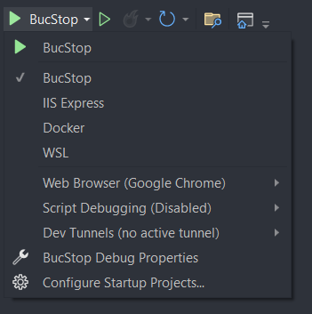

- Click the play button and it will run locally. It should open a web browser for you automatically.

Second Option: Running in a local docker container

Tips:

- Make sure docker is running in the background on your local machine when attempting the image build
- When running commands locally, check the file paths to match your OS. ie. using “\” on Windows and using “/” on Mac and Linux

- This project now utilizes a Docker Compose file. Navigate to the webapp directory containing docker-compose.yml and open this directory in your Terminal.

- First Time Setup:

  - The first time you are building the environment with image, container and volume, you will first need to run “docker volume create bucstop_json_data”. After running this, run “docker compose up -d –build”.

- Weekly Rebuild:
  - To rebuild weekly with the newest build, but not lose data in Docker Volume, navigate to directory with docker-compose.yml in terminal, and run “docker compose up -d –build”

- Go to the URL in a browser

  - http://localhost:8080

- If needed for rollback or other reasons, below are the commands to manually build the image and launch the container inside of Docker:

  - For BucStop:

    - docker build -f .\BucStop\Dockerfile --force-rm -

t bucstop .

  - For GameMicroService:

    - docker build -f .\GameMicroServer\Dockerfile --

force-rm -t gamemicro .

- Create a Docker Volume to store game submission files in:

  - docker volume create bucstop_json_data

- Run a local Docker container with the newly built image. You can run the command below:

  - docker run -d -p 8080:80 --name bucstopLocal -v bucstop_json_data:/app/data bucstop

  - docker run -d –p 4200:80 –name microLocal gamemicro

- Go to the URL in a browser

  - http://localhost:8080

